# Cit-E Lamp Server Tutorial

Within this tutorial, you will be shown how to download, enable, configure a lamp server and upload a webpage to the lamp server that you have enabled. This will be supplemented by comments and directional aids, such as screenshots of the page you are on in order to aid your navigation through this process. This will allow you to host your own data and website in a secure environment.

In order to ensure nobody is lost, this tutorial is using extremely basic language to ensure that people of all technical levels can understand it, as a result: I have assumed that you do not have basic software requirements (such as filezilla, VMware). If this is not the case, you can skip to the relevant section of the tutorial, using the contents page shown below.

Contents

Setting up the virtual machine 2

Installing VMware 2

Downloading the premade LAMP virtual machine 5

Launching a virtual machine 6

Verifying the server is installed correctly 11

Adding a webpage to the server 12

Installing Filezilla 12

Uploading a web file to the server 14

Testing the web file 15

# Setting up the virtual machine

## Installing VMware

Download link: <https://www.vmware.com/go/getworkstation-win>

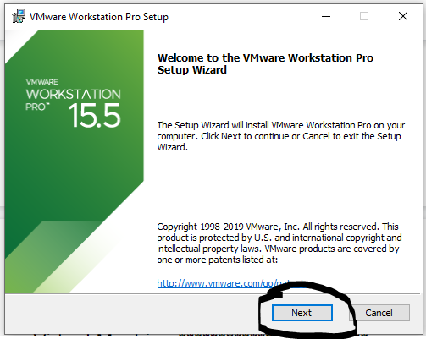

**Step 1: Setup wizard**

In order to begin the installation process of VMware, you must click the next button, as shown in the screenshot to the left. This will begin the installation process and allow you to host the virtualized LAMP server required for the competition’s web hosting.

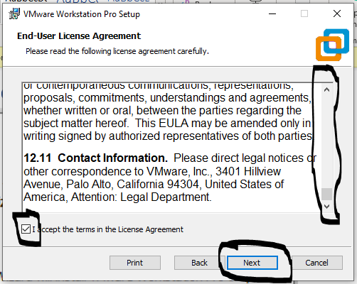

**Step 2: Terms and conditions**

Before the software will allow you to install the product, you must first read the terms and conditions, and then tick the box to confirm that you have read and agree to these terms and conditions, once this is done, you should click the next button: as shown in the screenshot.

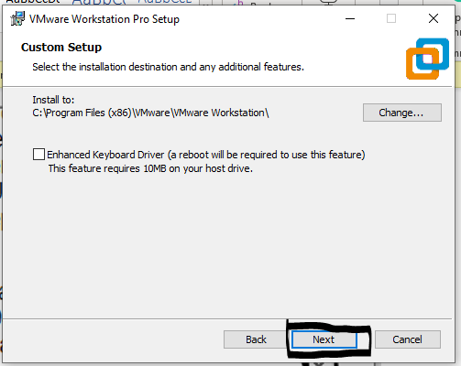

**Step 3: Installation location**

If you need to change the installation location from the default, click the “Change” button and select a new location, if this is not the case. Click the “next” button at the bottom of the dialogue window.

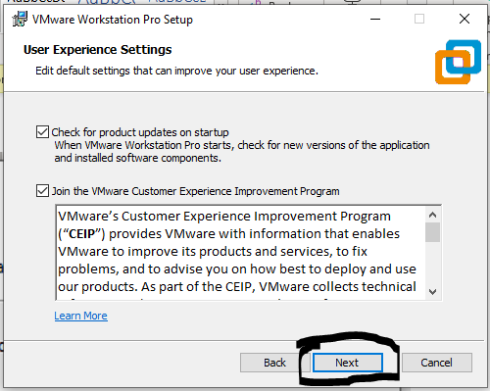

**Step 4: User experience settings**

This step allows you to opt in or opt out of the user experience monitoring system that VMware offers. This should be researched to determine if this is a good option to protect the data of school pupils. Once you are comfortable, click the “Next” button to proceed with the installation.

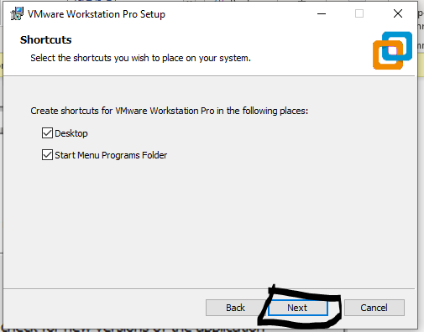

**Step 5: Shortcuts**

This box allows you to insert shortcuts into the computers. Thus, allowing you to easily start-up VMware from the desktop, without having to manually find the location of the file and launch VMware.

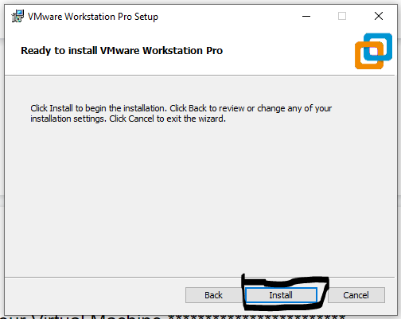

**Step 6: Confirmation**

In this window, you will be given a chance to review your previous selections, if you are happy with your previous selections, click the “Next” button to start the installation.

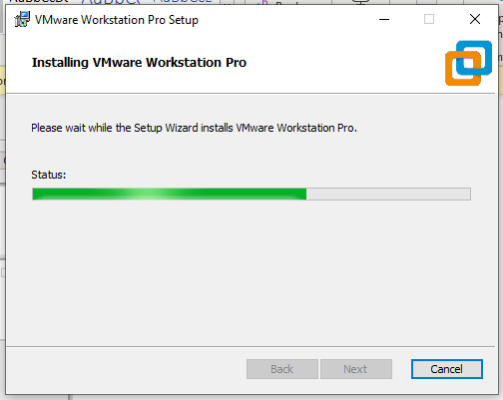

**Step 7: Installing**

This installation may take a while, please wait for this to finish. Once it’s finished, you may need to click “Next”. This will almost always quickly go to the next screen by itself.

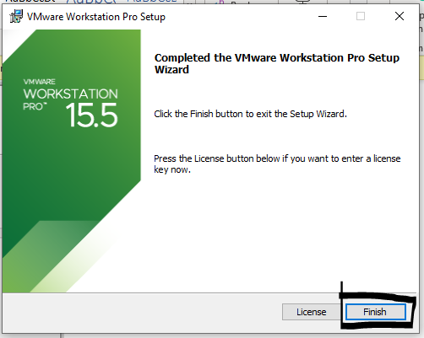

**Step 8: Finished!**

The installation has now finished. Click the finish button, this will finish the process and allow you to open the product.

## 

**Step 9: First time setup**

First, you need to click the windows icon in the bottom left corner of the desktop. Then you need to type in “Vmware” into the search box. You should then click on the VMware workstation Pro software; this will now open the vmware workstation program.

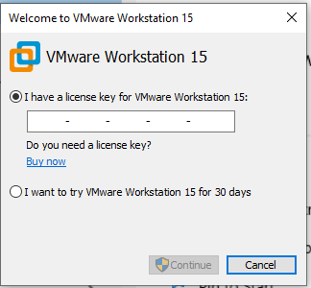

**Step 10: License key**

Insert your licence key here, this screen allows you to purchase a licence key. Once you have put your key into this screen, click the “Continue” button.

## Downloading the premade LAMP virtual machine

Download link: <https://marketplace.vmware.com/vsx/solutions/turnkey-lamp-appliance>

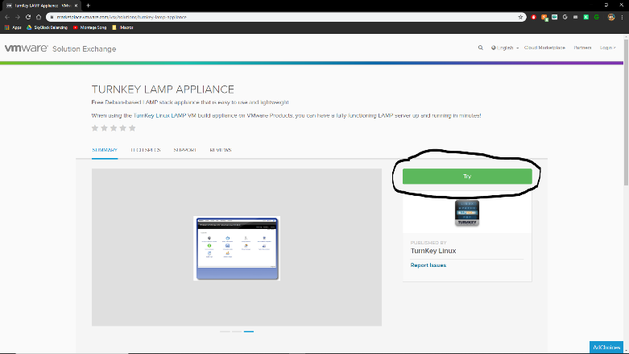

**Step 1: Clicking the download button**

In order to download the program, go to the download link, which is linked below, you will then need to click on the green try button (as shown in the screenshot).

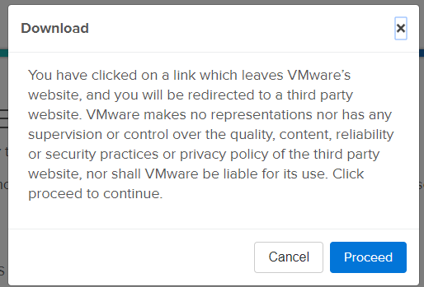

**Step 2: Confirmation window**

This window informs you that the machine is an unofficial/third party setup. This is fine as it’s created by a trusted source. In order to continue the download, click the “Proceed” button. This allows you to download it.

## Launching a virtual machine

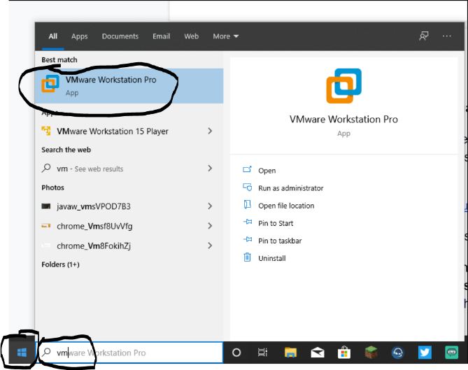

**Step 1: Open the program**

First, you need to click the windows icon in the bottom left corner of the desktop. Then you need to type in “Vmware” into the search box. You should then click on the VMware workstation Pro software; this will now open the vmware workstation program.

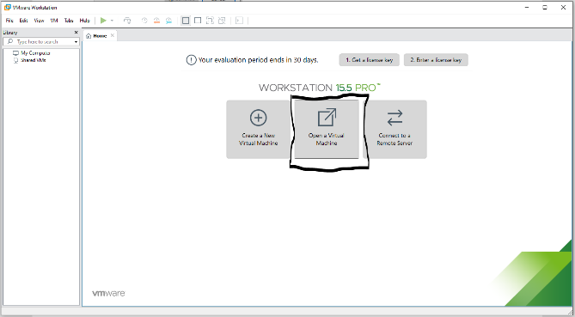**Step 2: Open a virtual machine**

As we have a premade virtual machine, we will need to open a virtual machine, rather than create it. This will setup the machine based on the image downloaded previously.

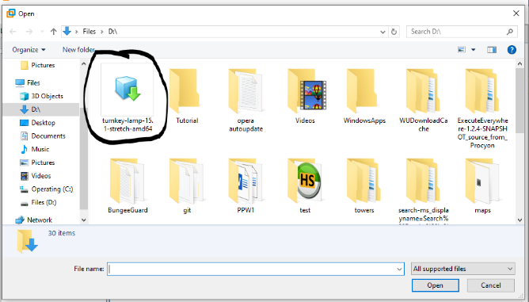

**Step 3: Locate the file**

You need to locate the previously downloaded file (from the previous section), on most machines this will be in the downloads folder of the machine itself, depending on the network settings.

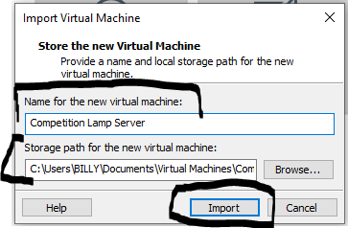

**Step 4: Name and select a location**

Now, you need to name the virtual machine, this is fully up to you to name, depending on your organisation’s naming convention. Select a storage path for your machine, this is where the machine’s files will be stored on the host machine.

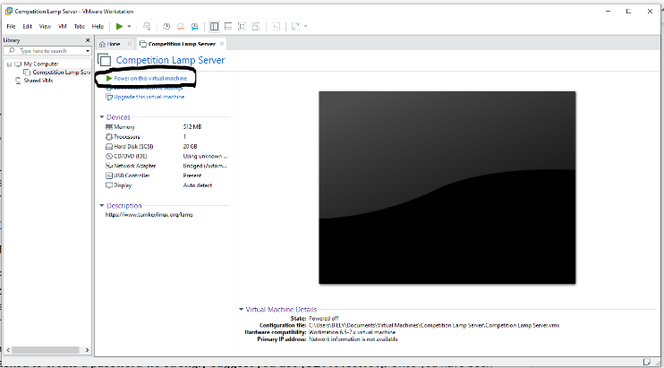**Step 5: First startup**

In order to generate the files for the first time, we must start-up the server. This will allow us to edit the network configuration settings to allow us to upload files to the machine and ensure it’s not connected to the internet.

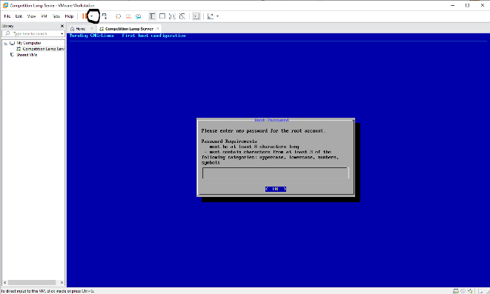

**Step 6: Stopping the machine**

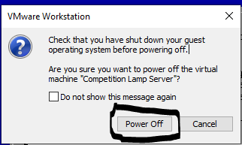Once this screen (top, blue screen) is shown to you, click the down arrow next to the pause icon on the top bar (shown in the screenshot). This will display a menu. You should then click the “Power off” button. You will then need to confirm your intentions by clicking power off again in the dialogue box. This will disable the machine and allow you to edit the configuration.

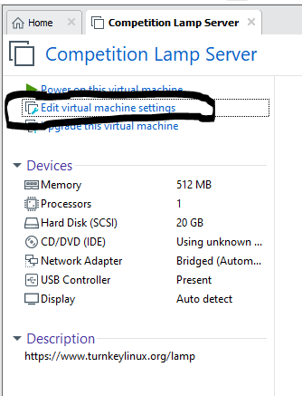

**Step 8: Network adapter change**

In order to ensure that we’re able to upload a webpage to the server, and to ensure that the device isn’t connected to the internet, so we can store data safely without worrying, we must edit the network settings. Click the button shown in the screenshot and proceed.

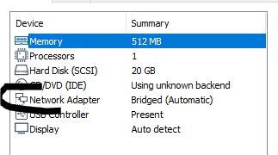In order to allow us to connect to the machine and upload files to the machine: we must change the network connection type from Bridged to “NAT”.

In order to do this: Click “network adapter”, then tick the “NAT” box. This will change the settings**.**

Once done, click “Okay”, this will apply the changes.

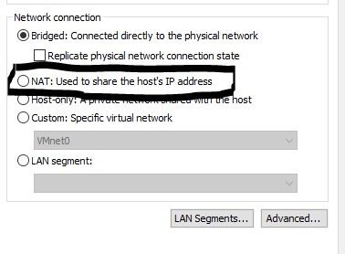



**Step 9: Start the server back up**

In order to continue and setup the machine’s passwords: we must now start up the server, click the start-up button (shown in the screenshot). This time, we will allow the server to run and will not be closing it down.

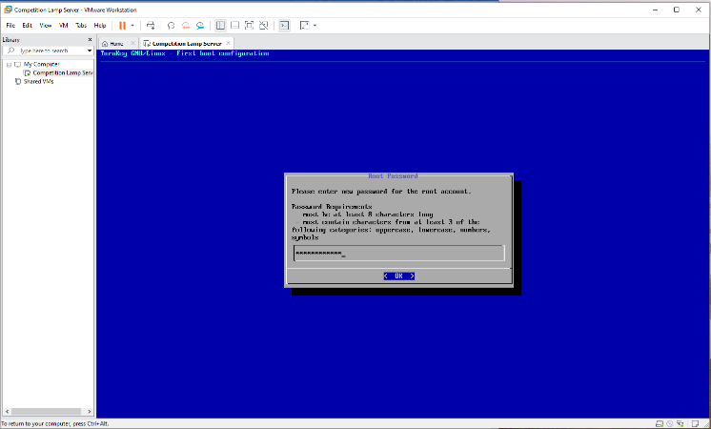**Step 10: Passwords and Security**

In order to ensure the machine is secure, we must set-up a password. This will allow us to login to the machine and upload files to the machine at a later point within this tutorial. Please read the requirements on screen and insert a password of your choosing. Once done, click the down arrow (keyboard), and then click enter (keyboard).

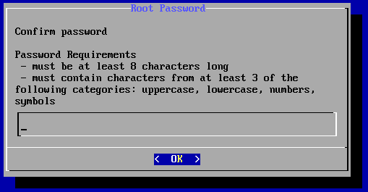

In order to confirm your password, you will be presented with a password confirmation screen, you must now confirm your previously entered password by repeating it. Once done, click the down arrow (keyboard), and then click enter (keyboard).

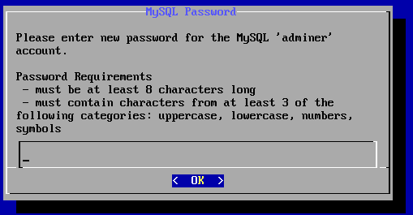This screen is asking for a MySQL password, this will not be used in this tutorial or for this purpose. However, you still need a password to be setup.

Please read the requirements on screen and insert a password of your choosing. Once done, click the down arrow (keyboard), and then click enter (keyboard).

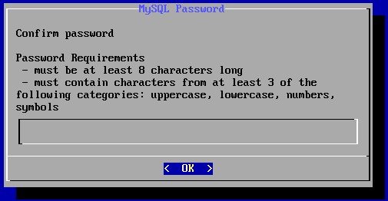

In order to confirm your password, you will be presented with a password confirmation screen, you must now confirm your previously entered password by repeating it. Once done, click the down arrow (keyboard), and then click enter (keyboard).

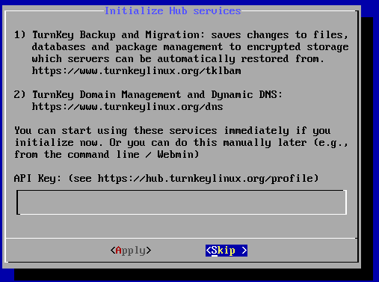

This screen is asking us to setup an API key for turnkey systems, as we will not be connected to the internet, we will skip this step.

**In order to do this, click the following:**

Down arrow

Right arrow

Enter

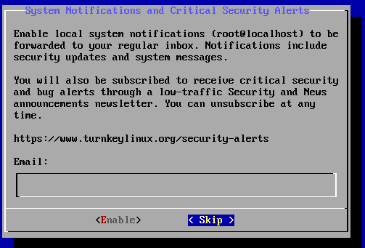This screen is asking to email you about critical security alerts: This is up to you to decide if you want to enable this. As we aren’t connected to the internet, we shouldn’t need to worry about potential vulnerabilities.

**To skip this step, click the following:**

Down arrow

Right arrow

Enter

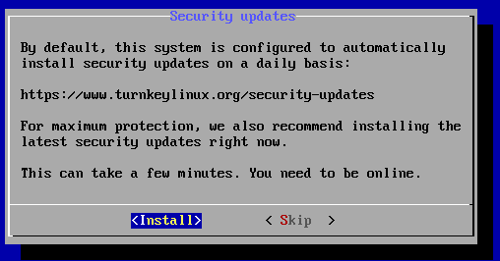This screen is asking to install updates automatically: As we’re not online, we don’t need to worry about automated security updates as they won’t be able to install automatically.

**To skip this step, click the following:**

Down arrow

Right arrow

Enter

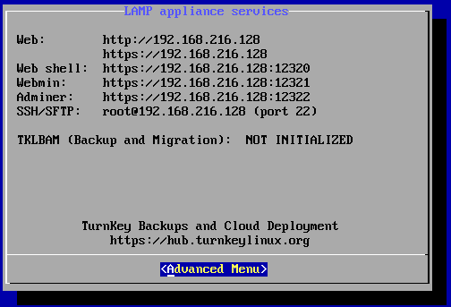

**Step 11: Very important information**

This screen shows us the ports and IP address assigned to the machine. This will allow us to upload the files to the server on the next section.

This should be written down somewhere, as you will need it in order to upload the webpage to the LAMP server.

## Verifying the server is installed correctly

In order to verify that your virtualized LAMP server is setup correctly and works, you should type in the IP address given next to “Web” into your host machine’s web browser. This should display the following webpage:

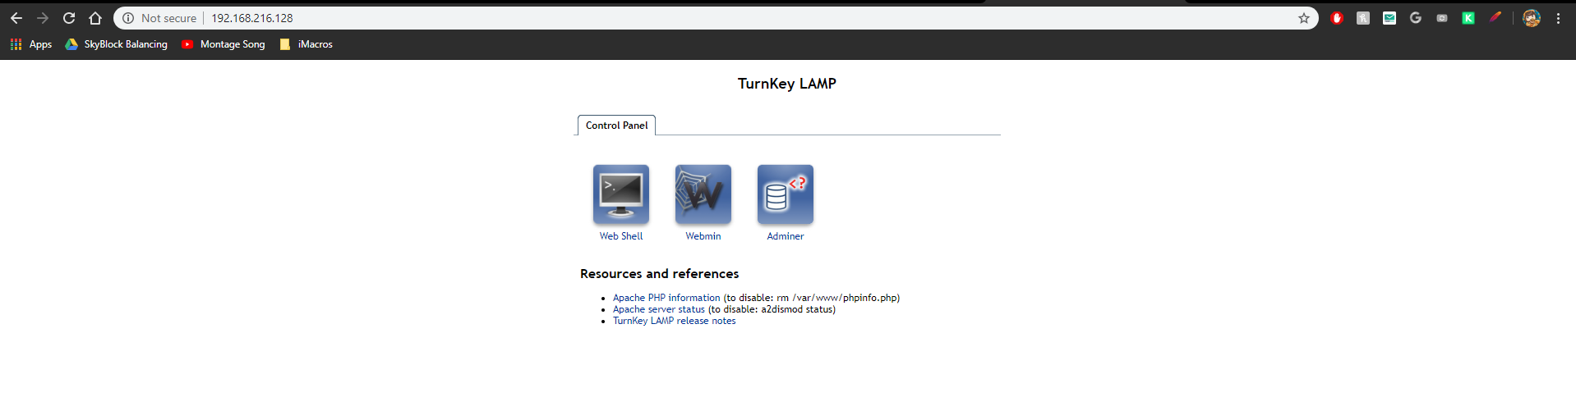

This means that the server has been installed correctly and your installation was successful, you are now able to move on to the next steps in order to upload a webpage to your server.

# Adding a webpage to the server

## Installing Filezilla

In order to upload the webpage to the local server, we will be using FileZilla. This allows for FTP connections, meaning we can upload the file to the server using a windows-based GUI.

Download link: <https://filezilla-project.org/download.php?type=client>

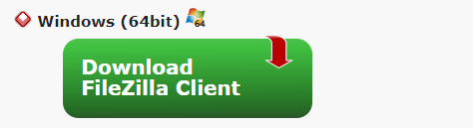

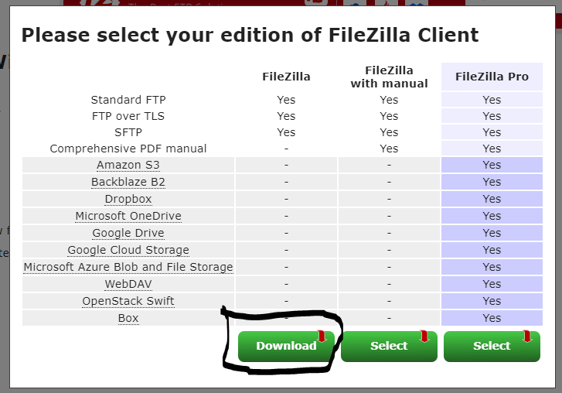**Step 1: Download**

Click to download the windows version of FileZilla client: this allows us to upload to the server we have just setup.

Click download on the filezilla column, this will download filezilla onto the computer. Allowing us to upload the files in the next section.

**Step 2: Starting the install process**

In order to begin the install process, we must click the exe file. This will launch FileZilla’s install wizard, allowing us to continue with the installation process and have the product on our machine.



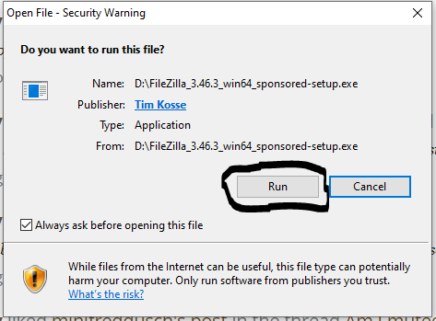

**Step 2: Running the exe file.**

In order to install, we must allow the program permissions on our machine, this will allow the software to install itself onto the machine.

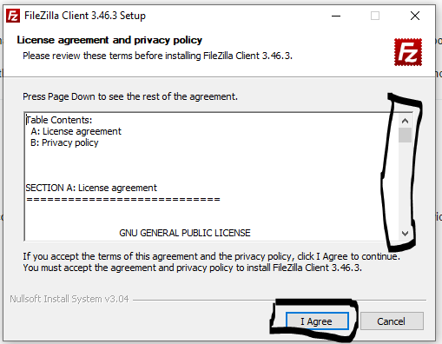

**Step 3: Terms and conditions**

Before the software will allow you to install the product, you must first read the terms and conditions, and then tick the box to confirm that you have read and agree to these terms and conditions, once this is done, you should click the next button: as shown in the screenshot.

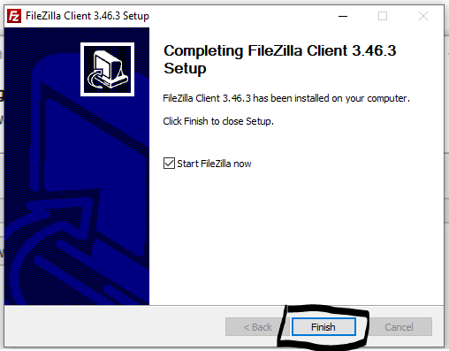

**Step 4: Finish the install**

In order to finish the install, click the “Finish” button, as shown in the screenshot: this will finish installing and allow you to launch the filezilla program.

## Uploading a web file to the server

**Step 1: Typing in the details**

You need to open the filezilla application, then type in the details. These details were shown on the blue screen on the LAMP server, as shown in Step 11 (Page 10). **Your details will not be the same as shown below.** The username by default is “root”. The password will be the password you assigned during the setup stage.

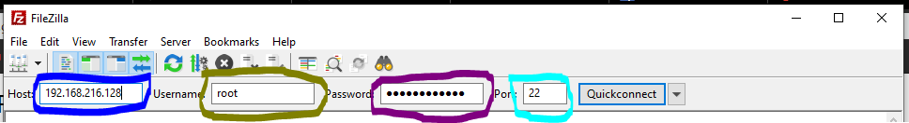

Once you have typed in your details, click the “Quickconnect” button.

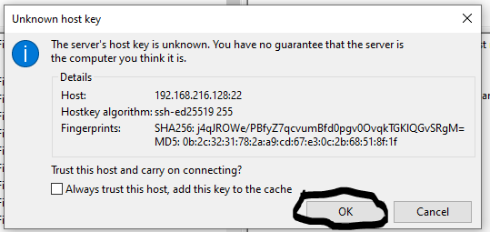

If you are shown this screen, click “OK”, as we know that the source and host of this device is accurate and is hosted by ourself, thus making it secure to connect to.

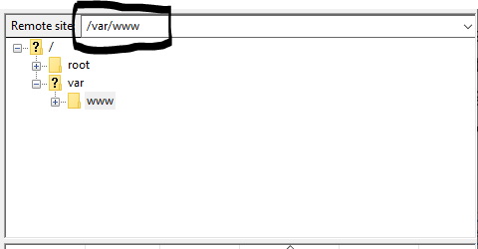

**Step 2: Locating the web directory**

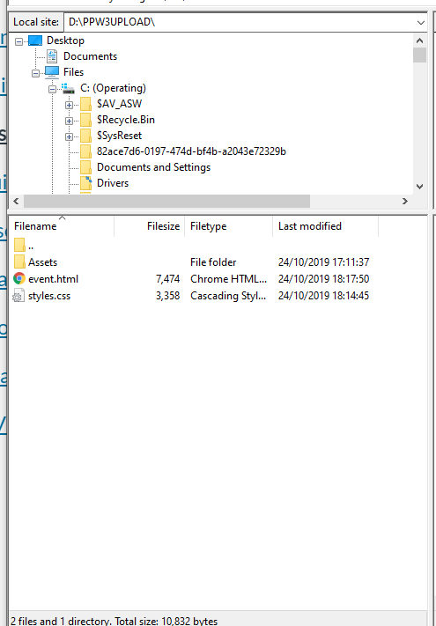In order to upload to the web area of the server, we must navigate to “/var/www”, you need to type this into the remote site box, as shown in the screenshot. This will give us access to the web file area.

**Step 3: Uploading the file(s)**

In order to upload the file: first you must locate the file you are wanting to upload, you can either type the file path into “Local site”, or use the top left navigation window to browse through folders in order to find the correct path. Once done, drag the files from your local folder into the bottom right window (opposite)

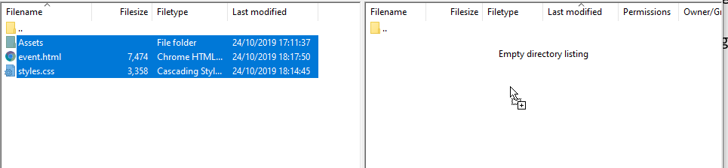

## Testing the web file

In order to test to see if the file upload was successful, use the server’s I.P. address (the one given on your screen during step 11, page 10). And type this into a web browser.



Note: If your main page is not called index.html: you will need to include the path in order to test that this works (for example: <http://192.168.216.128/event.html>). This is because the browser looks for the index page by default. Consider renaming your page to index.html if this is the case.

This should display the file that you have uploaded to the web server, for example:

